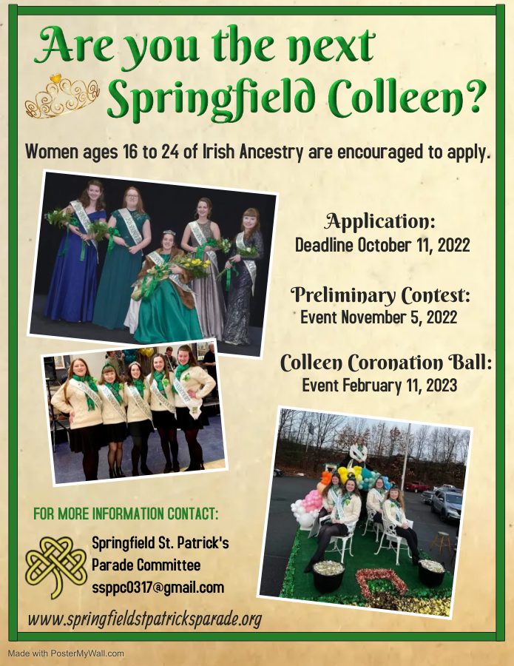
September 12, 2022

For Publication:

Applications for the 2023 Springfield St. Patrick’s Parade Colleen contest are available at the guidance office of our local high schools, colleges and Universities. Applications are also available at Springfield St. Patrick's Parade Committee's website and our Facebook page. The applications can also be found at the John Boyle O’Reilly Club’s downstairs membership lounge at 33 Progress Avenue, Springfield MA, their website www.JBO-Club.com and their Facebook Page.

Applications must be postmarked by Tuesday, October 11, 2022.

Contacts: Alesia Barbaro at 413-478-8611 or Mollie Sullivan at 413-237-7969

Table of Contents
2023 COLLEEN CONTEST DETAILS 4
2023 SPRINGFIELD COLLEEN CONTEST APPLICATION 5
COLLEEN QUESTIONS 6
2023 COMMITMENT LETTER 7
2023 PERMISSION TO USE PHOTOGRAPH AND BIOGRAPHICAL INFORMATION 8

2023 COLLEEN CONTEST DETAILS

This is the official application for the 2023 Springfield Colleen Contest. Please follow the instructions on each application carefully.

Included in this package is an application for the 2023 colleen contest. Each of the five Colleen finalists will be eligible for the Mossie and Kathleen Murphy Scholarship. Applications for the scholarship will be provided to finalists after the preliminary event.

Please follow all directions on all forms and return your application with all the required documents to Springfield St. Patrick’s Parade Committee, c/o Alesia Barbaro, 182 Miller Street, Ludlow, MA 01056. Your applications must be postmarked no later than Tuesday, October 11, 2022.

The preliminary contest is planned for November 5, 2022 at The Carriage House at the Barney Estate at Laurel Hill Rd, Springfield, MA 01108. The Coronation Ball will be held Saturday, February 11, 2023 at Sheraton Springfield Monarch Place, 1 Monarch Place, Springfield, MA 01144.

Contacts: Alesia Barbaro at 413-478-8611 or Mollie Sullivan at 413-237-7969

Wishing you the best of luck,
Colleen Committee
Springfield St. Patrick’s Parade Committee

2023 SPRINGFIELD COLLEEN CONTEST APPLICATION

Eligibility

Young women of Irish Descent, are 16 to 24 years of age, single (never been married or never had a child) and is at least a High School junior. Residents of Springfield, East Longmeadow, Hampden, Longmeadow, Ludlow or Wilbraham are eligible. (Residents of other towns MAY be eligible.) Former Colleens and members of the Court are NOT eligible.

Personal Information

Name________________________________________________________________________
Father’s Name_________________________________________________________________
Mother’s Name_________________________________________________________________
Mother’s Maiden Name__________________________________________________________
Address______________________________________________________________________
City_______________________________________________________Zip________________
Home Phone_____________________________ Cell Phone____________________________
E-mail _______________________________________________________________________
Date of Birth_______________________________________________ Age________________
School__________________________________________________ Grade________________

Please enclose a recent wallet size picture of yourself (.jpeg format) along with the application and your response to the Colleen questions.

Applications, including all required documents and photos, must be postmarked no later than
Tuesday, October 11, 2022.

Send application to:
Springfield St. Patrick’s Parade Committee
C/O Alesia Barbaro
182 Miller Street
Ludlow, MA 01056

If you have any questions, please call Alesia Barbaro at 413-478-8611 or Mollie Sullivan 413-237-7969.

COLLEEN QUESTIONS

Answer for all four questions should not exceed two pages total, anything more will not be read.

1. How has your Irish heritage helped to shape the person you are today? Your answer should include what it’s like growing up in an Irish family and how the Irish culture has influenced you.

2. Please discuss briefly: a) the contributions you have made to both your Irish and local community and b) your school activities.

3. If your friends and family could describe you in only three words, which words would they choose and why?

4. What qualities do you like most about yourself and why?

2023 COMMITMENT LETTER

Dear Colleen Contestant,

At this time, we would like you to consider the commitment we will be expecting from you should you become a finalist.

- The five finalists are required to attend ALL functions to which the Colleen and her Court are invited.

- You will be required to provide your own transportation and arrive on time to each event.

- You are expected to appear at ALL events unescorted. No friends should be on hand to meet you; you will be unable to spend time with them.

- Contestants and parents, you will be provided with a list of events and the appropriate attire the contestants will be expected to wear at each event The Coronation Ball will be Saturday, February 11, 2023 at Sheraton Springfield Monarch Place, 1 Monarch Place Springfield, MA 01144.

- We ask that contestants choose a significant male person in their life as an escort during the contest portion of the evening. A father, uncle, or a brother is an appropriate choice. We do not want a boyfriend as an escort. This position is reserved for someone who has known you throughout your life and has made an important, positive impact on you.

- Should you be chosen the Colleen, the trip to Ireland must be taken by the end of January 2024 or it is forfeited.

Contestant Signature: __________________________________________________________

Parent/Guardian Signature: ______________________________________________________

Date: ____________________________

2023 PERMISSION TO USE PHOTOGRAPH AND BIOGRAPHICAL INFORMATION

I authorize the Springfield St. Patrick’s Parade Committee to use photographs of me and biographical information found on your application and brief biography for educational or promotional purposes in any type of media, including our website.

Date: ________________

Contestant Signature: ___________________________________________________________

Printed Name: _________________________________________________________________

(Parent/guardian Signature if the applicant is not 18)

Date: _________________

Parent/Guardian Signature: _____________________________________________________

Printed Parent/Guardian Name: __________________________________________________

